It is quit useful to have a quick overview of house price vs month and year

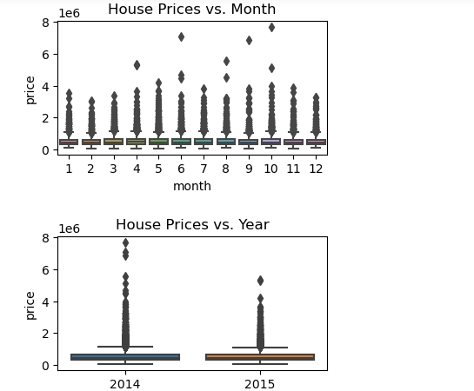

we have predicted the house price using three different ML model algorithms.

The score of our **Multiple Linear Regression** is around 70%, so this model had room for improvement. The score of our **Bayesian Regression** is around 70%, so this model had room for improvement. Then we got an accuracy of ~74% with **Keras Regression model**.  
Also, notice that RMSE (loss function) is lower for Keras Regression model which shows that our prediction is closer to actual rating price.



